BIO INFORMATICS

Project Report Task 2

How to Run the Program

1. Download the necessary pdb files that you want to test on and also projectbio.py and put them in the same folder.
2. Open Command Prompt or SSH or Putty or Python Shell or Codeblocks and navigate to the file where it is saved.
3. I did it in Command Prompt, so we need to navigate to the place where both the files are saved.
4. Type cmd in run and open it.
5. Type python projectbio.py in cmd and press enter.
6. 3 new file would be created with the file names sidechainoutput.pdb, betaoutput.pdb, helixoutput.pdb.
7. I tested my program with the following pdb’s
   1. 1aky
   2. 1aop
   3. 2p8y
   4. 1flp
   5. 1so4 and many more
8. You can open the output files in chimera and verify the results.
9. I am attaching some screenshots of my output here
10. 
11. Side Chain atoms without integrating with full protein structure
12. 
13. Same side chain atom along with original protein structure for verification
14. 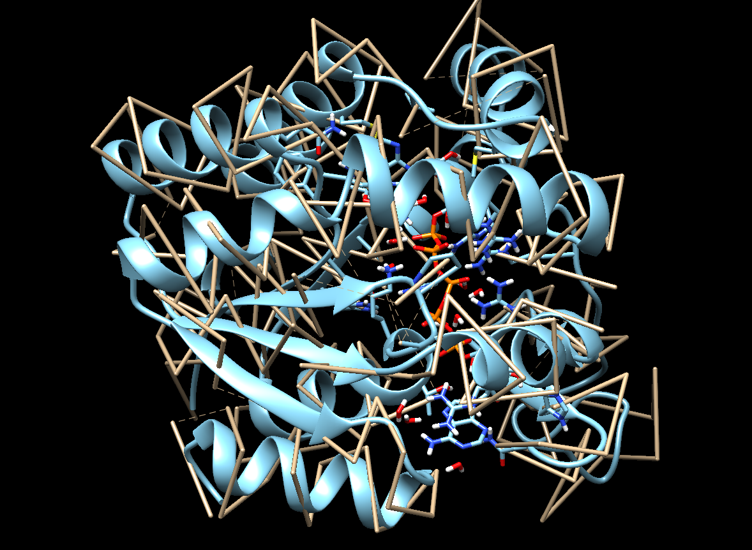
15. Helix atoms without integrating with full protein structure
16. 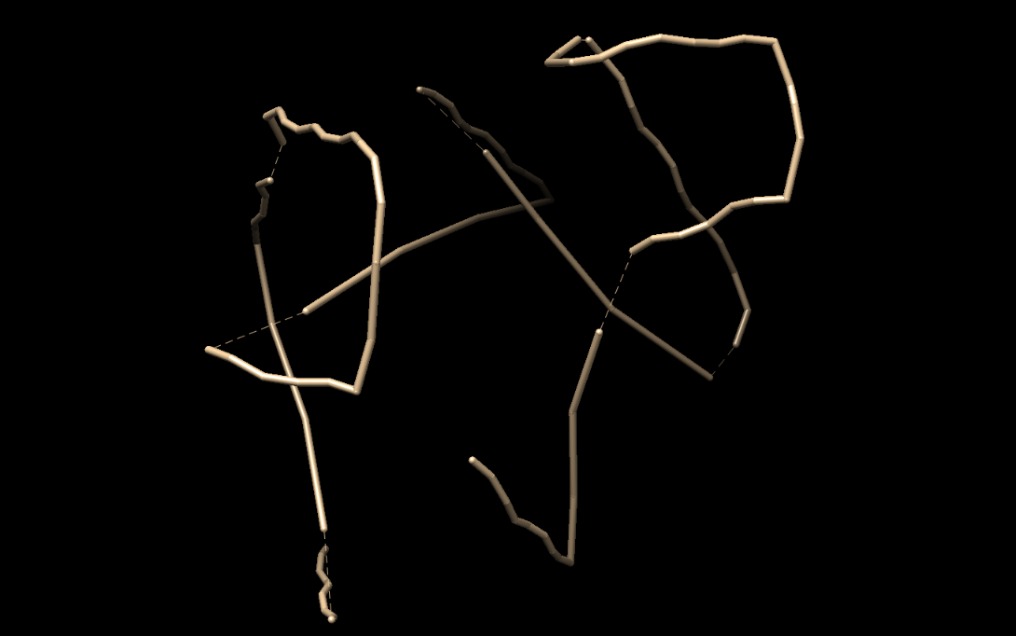
17. Same helix atoms along with original protein structure for verification
18. 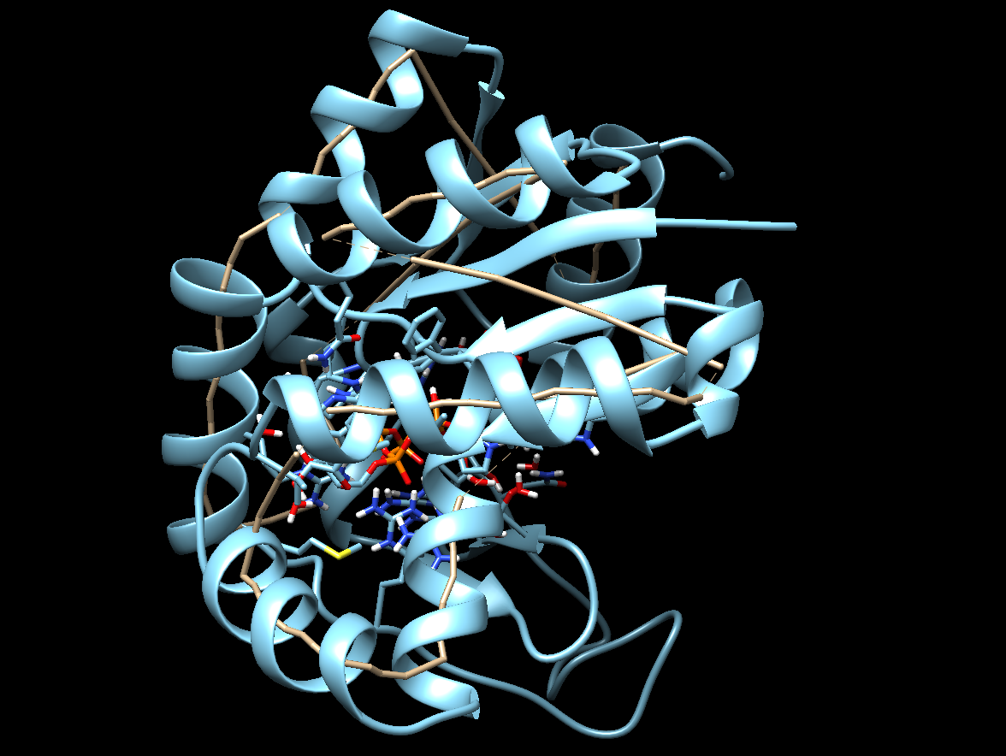
19. Beta Strand atoms without integrating with full protein structure
20. 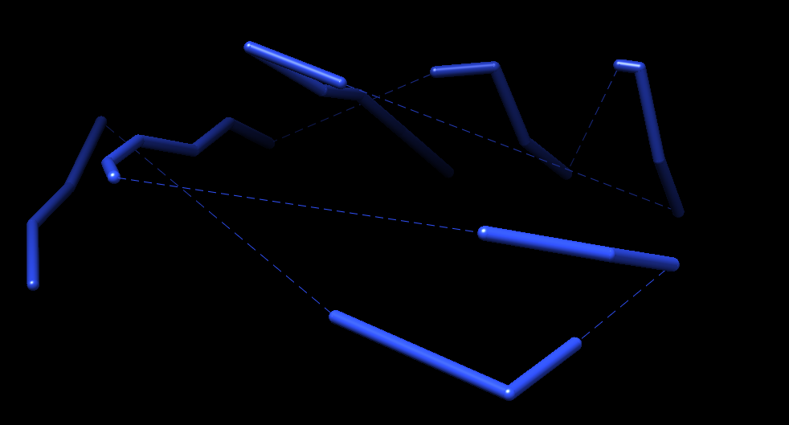
21. Same Beta Strand atoms along with original protein structure for verification
22. 